**MIND YOUR LANGUAGE**

**And connect interprofessionally**

Meet and greet studiers you don’t yet know and discuss the following calls to action.

Co-create meaning on how Specialist Teachers can be MINDFUL of LANGUAGE,

and expand your network of practice across endorsements and regions.

What are some examples of deficit, exclusionary or binary language which you as a Specialist Teachers can positively reframe to support more inclusive practices?

_________________________________________________________________________________________________________________________________________________________________________________________________________________________________________________________________________

__________________________________________________________________________________________________________

INCLUSIVE LANGUAGE

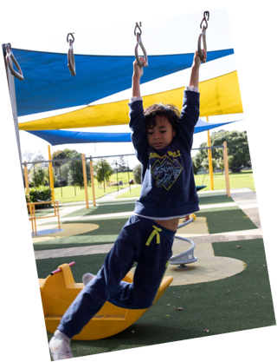

Studier/s name/s, endorsement/s & regions : ___________________________________________________

New take-away from the interprofessional kōrero : ____________________________________________________

What are the causes of the near extinction of Pacific languages ? How can you as a Specialist Teachers promote Pacific languages and identity?

________________________________________________________________________________________________________________________________________________________________________________________________________________________________________________________________________________________

**PACIFIC LANGUAGES**

Studier/s name/s & endorsement: ________________________

New take-away from interprofessional kōrero: _______________________________________________

**NZ SIGN LANGUAGE**

What is Deaf Identity and how can you as a Specialist Teachers promote our second official language?

__________________________________________________________________________________________________________________________________________________________________________________________________________________________________________________________________

___________________________________________

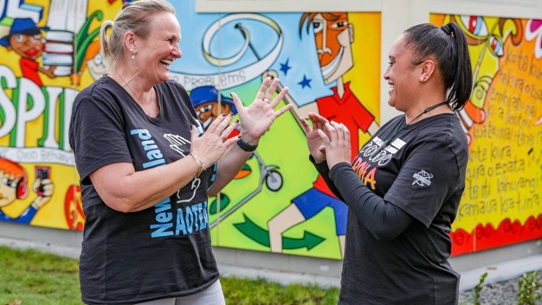

Studier/s name/s, endorsement/s, region/s: __________________________________

New take-away from interprofessional kōrero: _______________________________________________

What is AAC and what do those with lived experience want us to know? How can you as a Specialist Teachers use AAC?

___________________________________________________________________________________________________________________________________________________________________________________________________________________________________________________________________________________________________________________________

 AAC

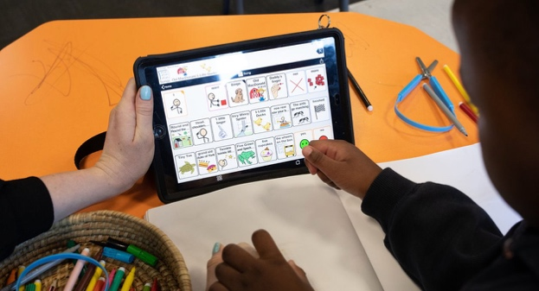

S

Studier/s name/s, endorsement/s, region/s: ________________________________________________

New take-away from interprofessional kōrero: _______________________________________________

PLAIN LANGUAGE

What is Plain Language – and when should you as a Specialist Teachers use this (and when not)?

____________________________________________________________________________________________________________________________________________________________________________________________________________________________________________________________________________________________________________________

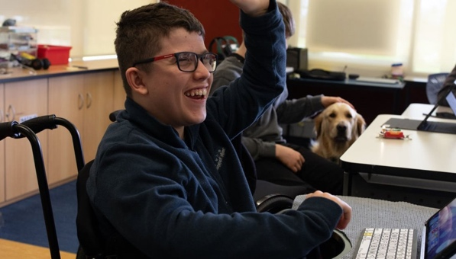

Studier/s name/s, endorsement/s, region/s: __________________________________

New take-away from interprofessional kōrero: _______________________________________________

**Kōhanga Reo**

**& Korowai Mokopuna endorsement**

What is the kaupapa of the Kōhanga Reo and the Korowai Mokopuna endorsement? What networks can we make as Specialist Teachers?

__________________________________________________________________________________________________________________________________________________________________________________________________________________­­­­­­­­­­­_______________  
__________________________________________________________________________________________



Studier/s name/s, endorsement/s, region/s: __________________________________

New take-away from interprofessional kōrero: _______________________________________________

[ADD YOUR ENTRY in MOODLE](https://masseyuniversity.mrooms.net/mod/glossary/view.php?id=13651&forceview=1) OF **- MIND YOUR LANGUAGE -** and BE IN THE DRAW!!

Add your image *OR* screenshot *OR* quote from a studier *OR* example from your practice OR website *OR* journal article *OR* blog post *OR* meme *OR* podcast *OR* cartoon that signifies MIND YOUR LANGUAGE